ART-Pop Lit

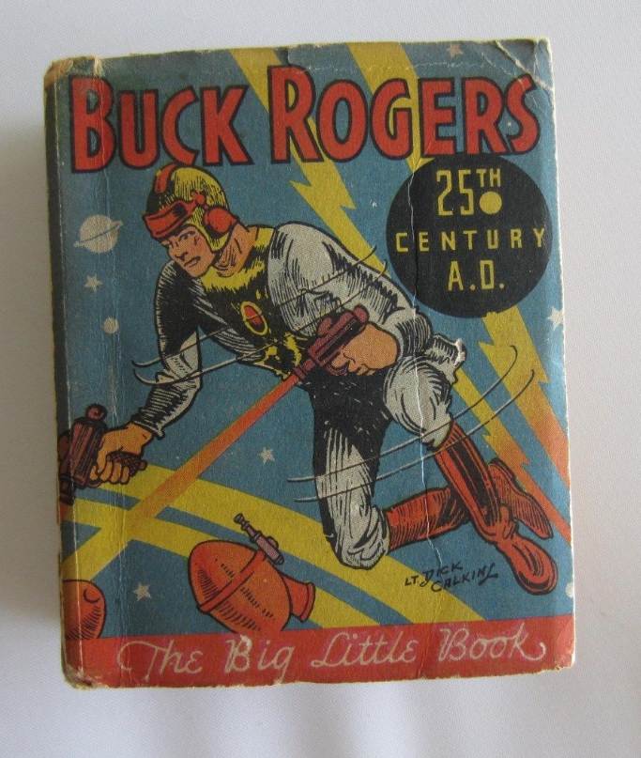 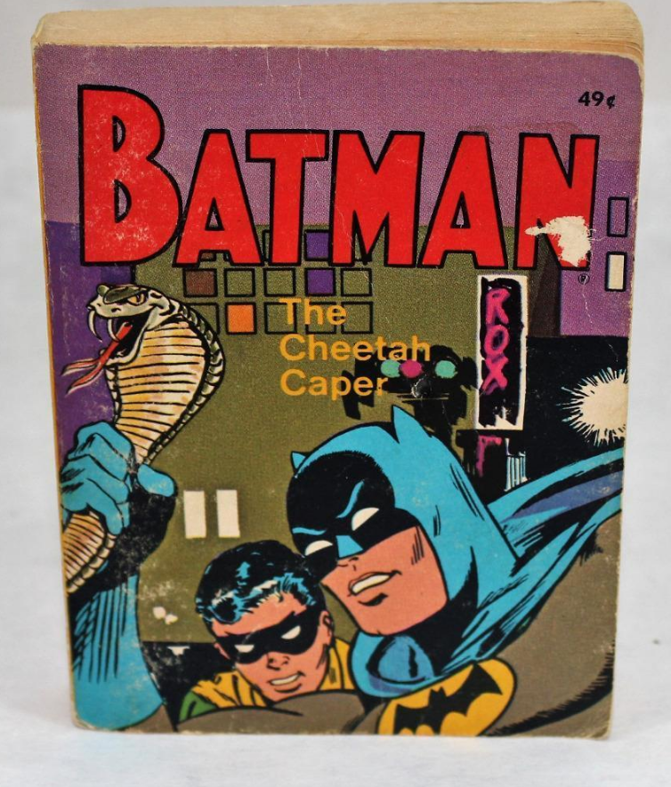 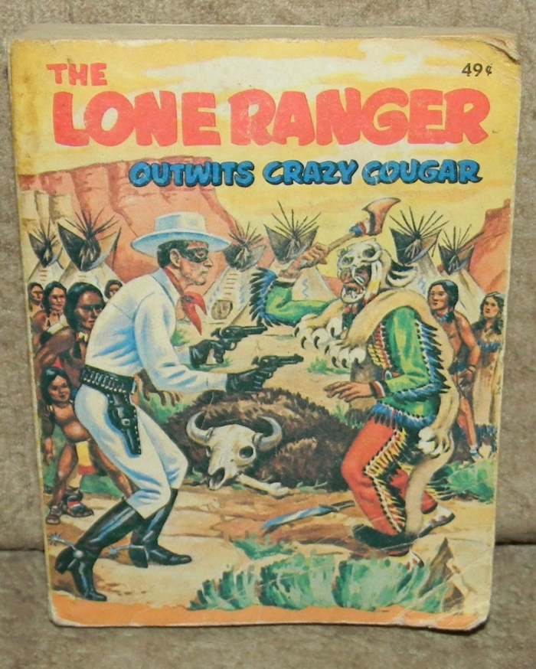1968

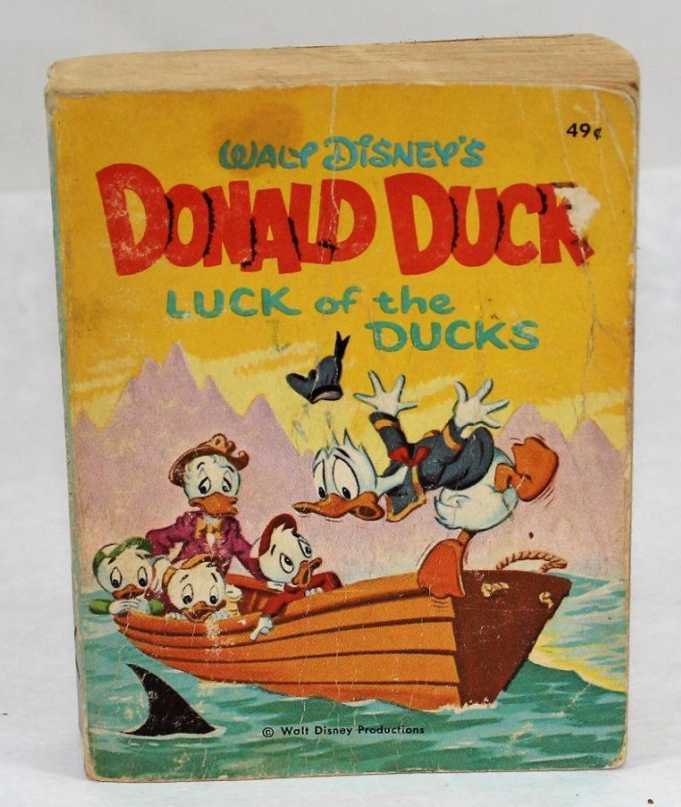

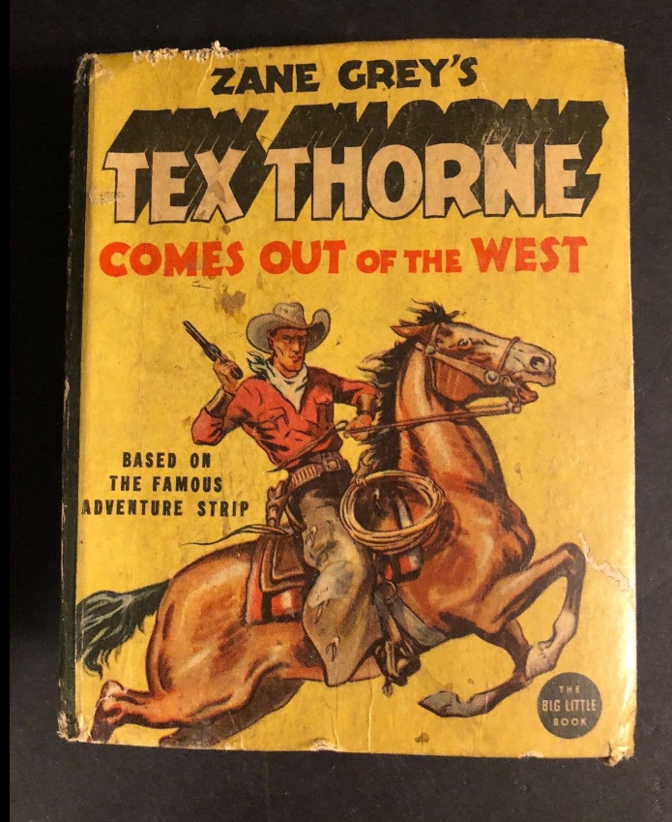

1938

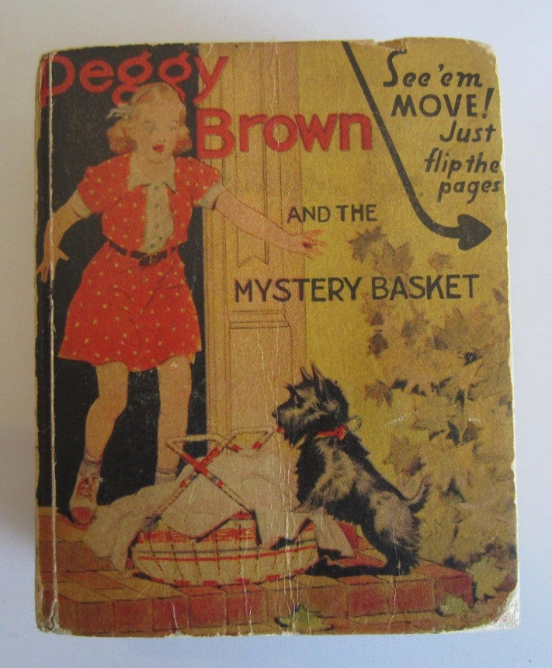

1941

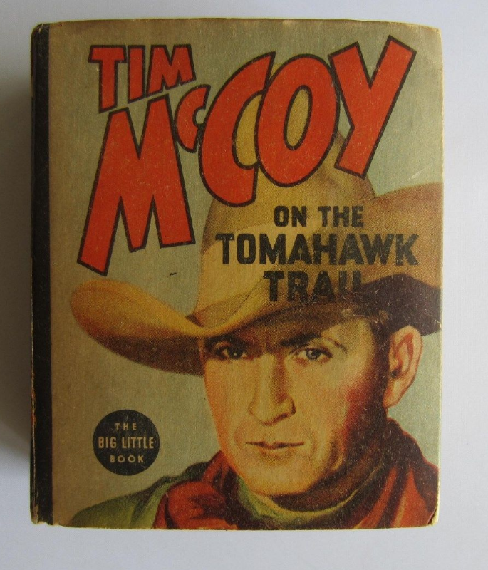

1938

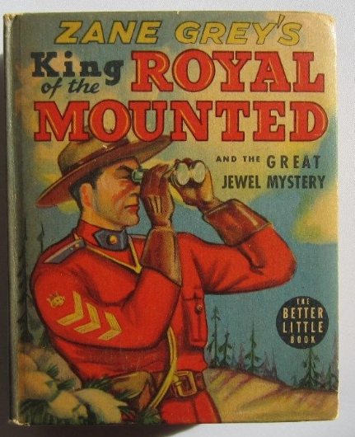

1939

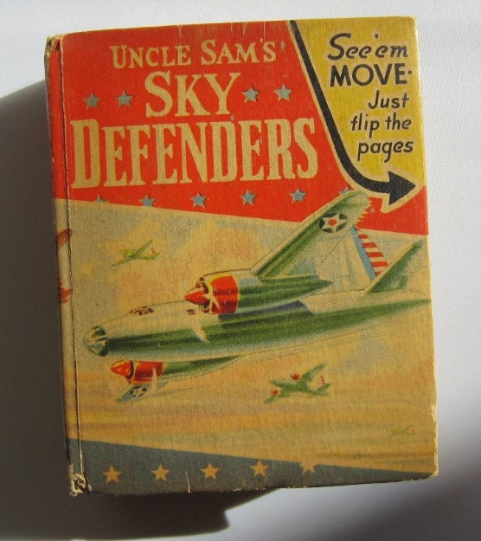

1941

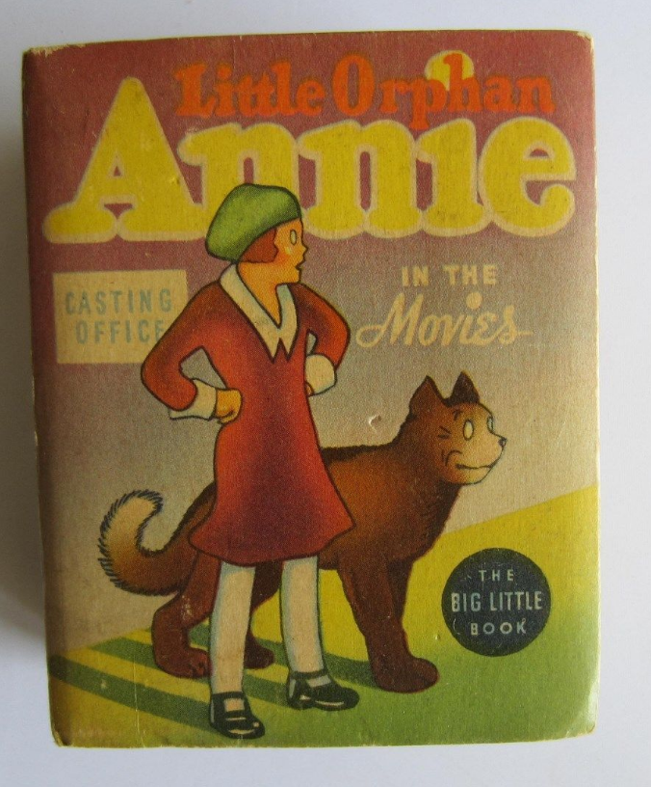

1938

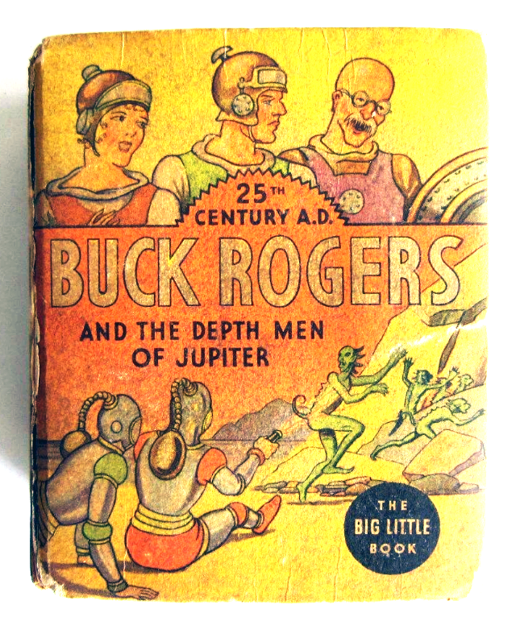

1938

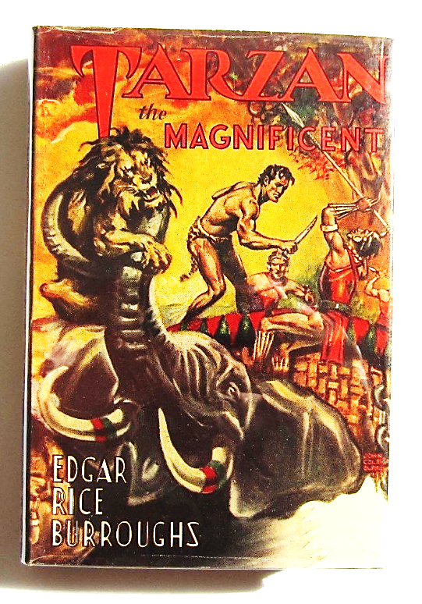

 published by Edgar Rice Burroughs Inc. Tarzana Ca. before 1958. An applied sticker with a signed and dated statement that this copy is a survivor of the 1958 fire at the publisher's warehouse on the pastedown.

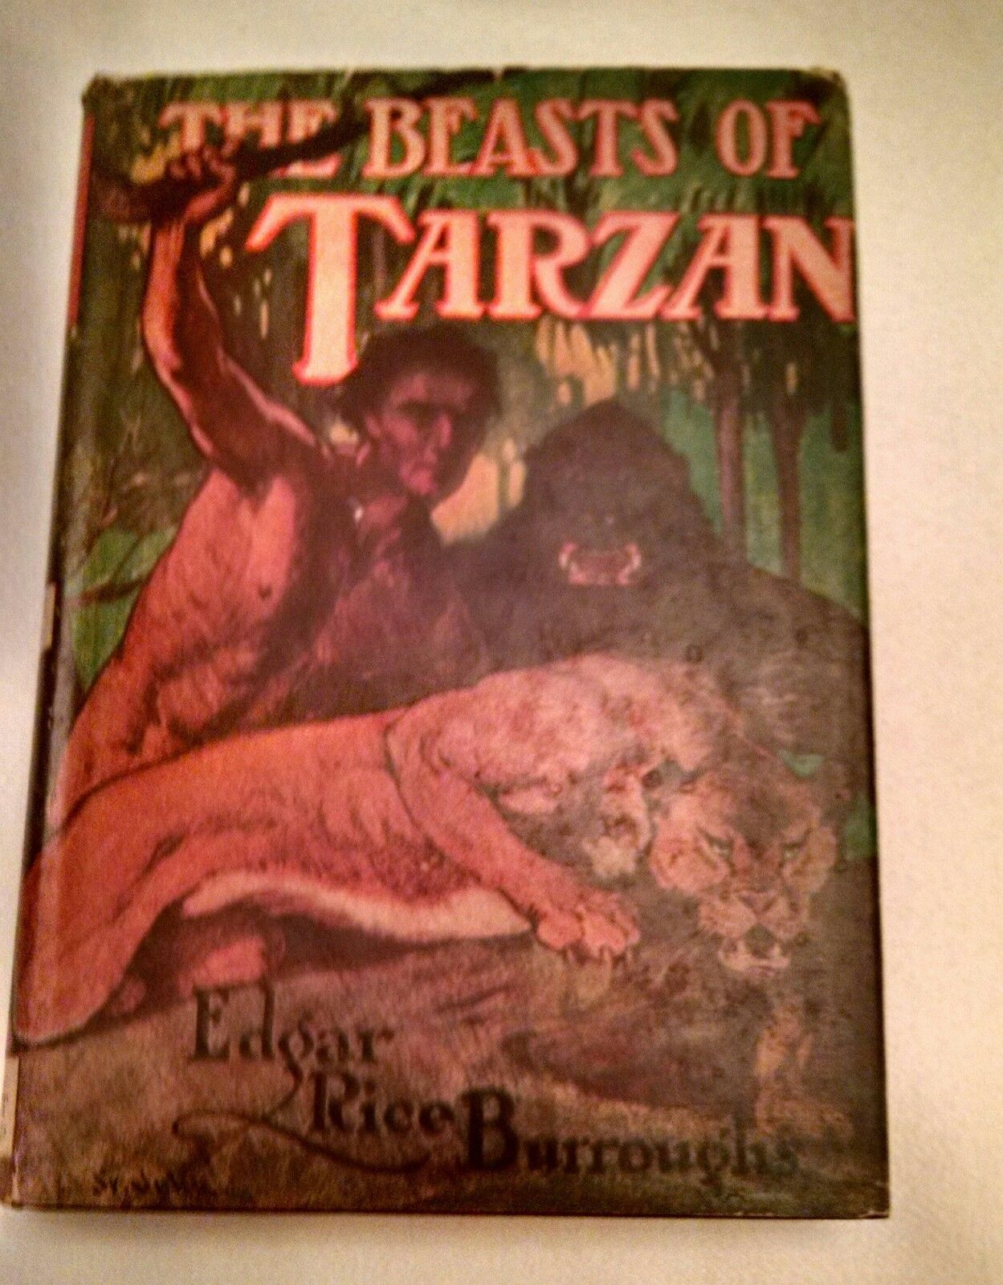 

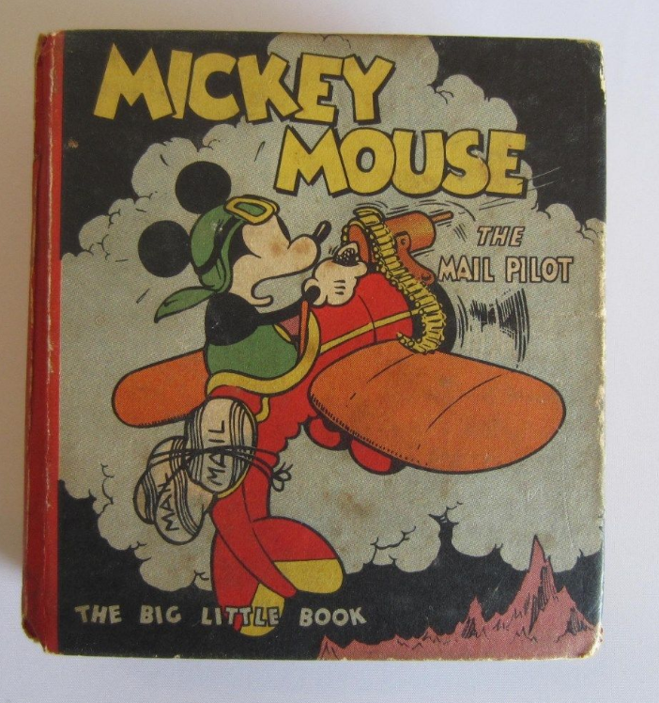

Whitman Publishing Co. # 731 published in 1933 , copyright Walt Disney Studios.

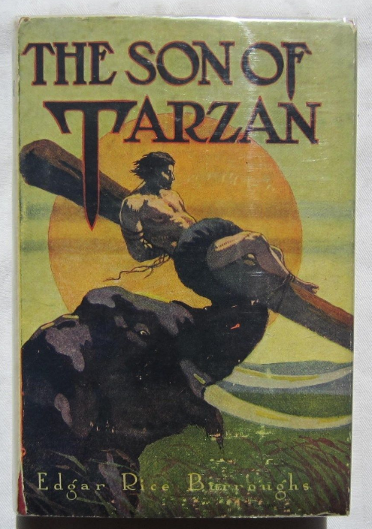

Son of Tarzan by Burroughs. Grosset & Dunlap reprint date unknown , with early design DJ.

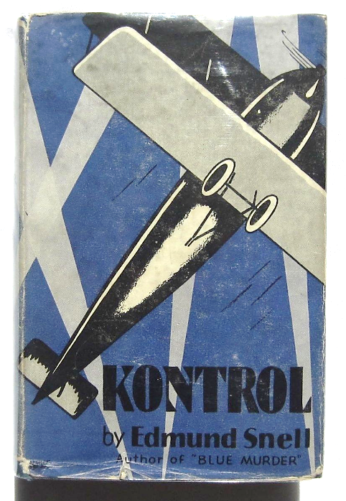

Kontrol by Edmund Snell. J.B. Lippincott Company , Philadelphia , 1928.

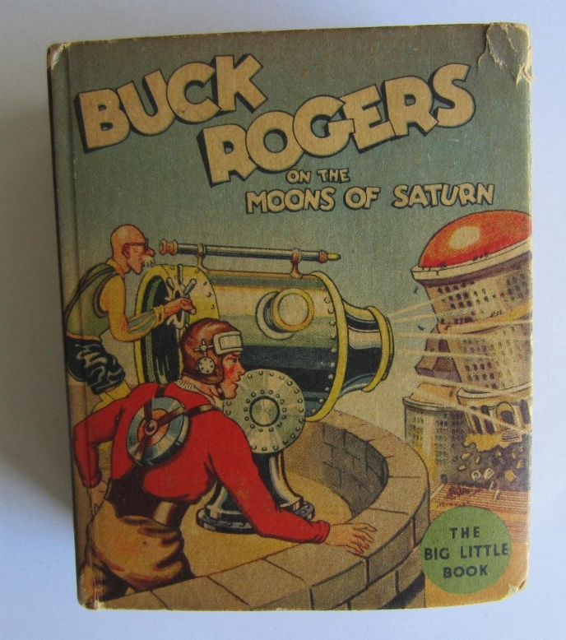

 Whitman Publishing Co. # 1143 published after 1934 .

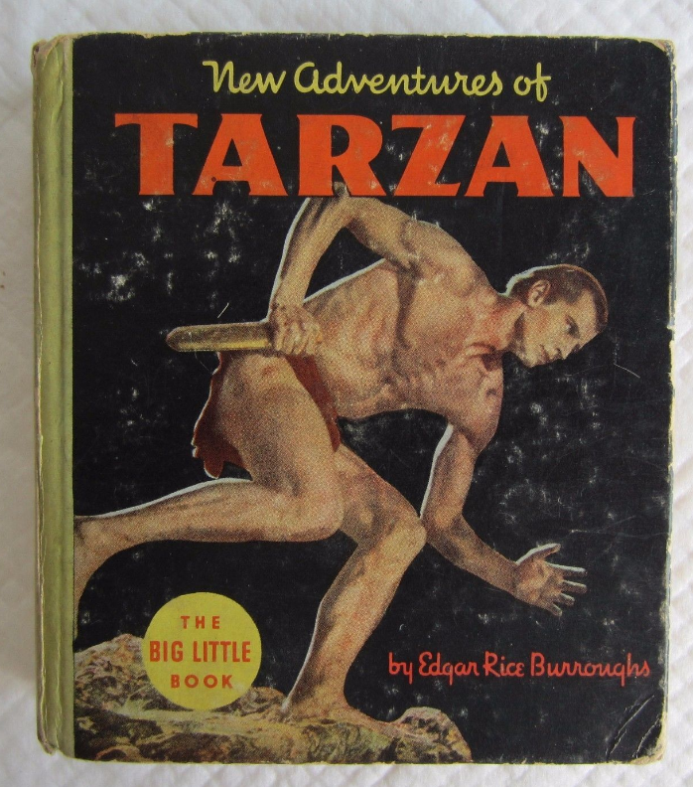

New Adventures of Tarzan - Big Little Book . Whitman Publishing Co. # 1180 , with scenes from the film starring Herman Brix & Ula Holt

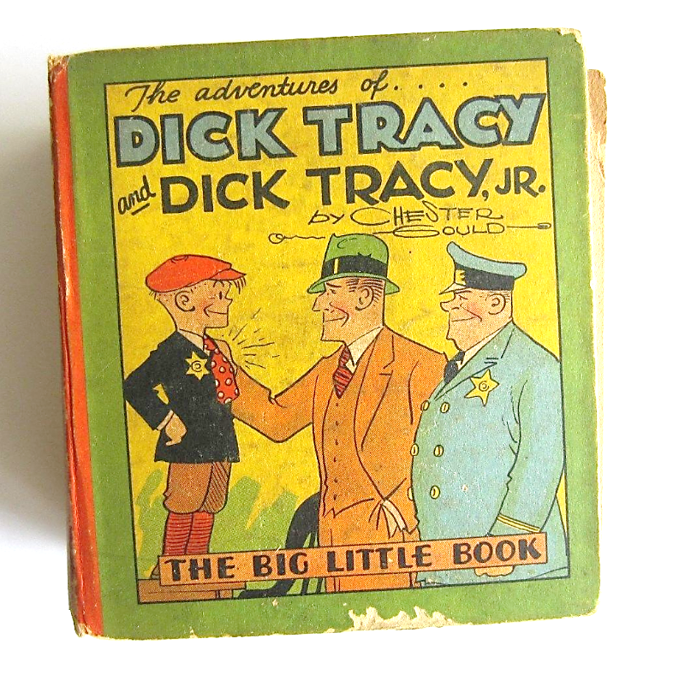

 Whitman Publishing Co. # 710 published after 1933 .

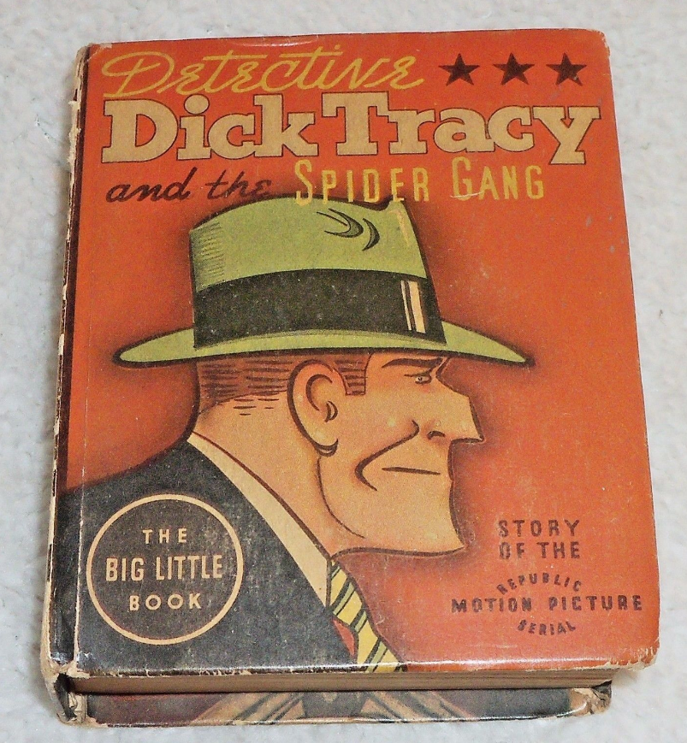

**DICK TRACY and the SPIDER GANG Better Little Book 1937 BLB #1446; every other page has a still photo from the motion picture**

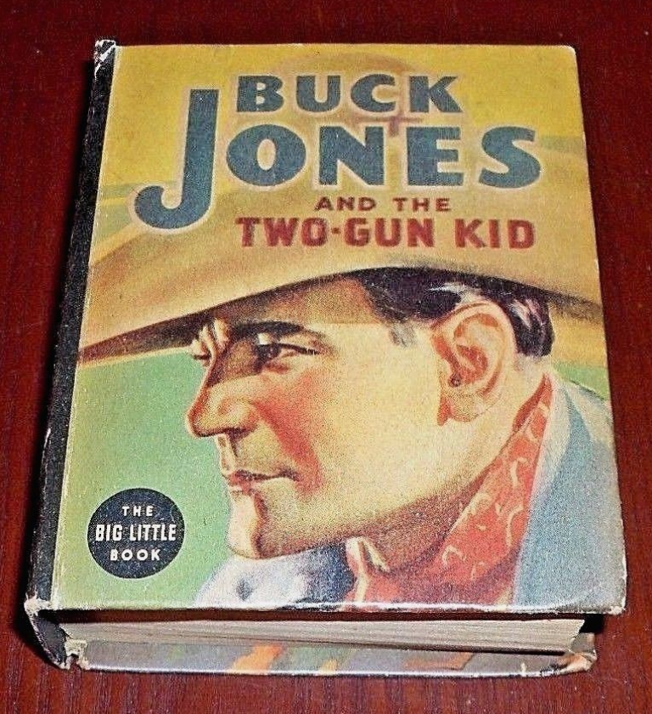

### BUCK JONES AND THE TWO-GUN KID 1937 Better Little Book BLB #1404 [/](http://www.ebay.com/itm/1981-Star-Wars-Return-of-the-Jedi-Marvel-Comic-Book-Set-1-4-Movie-Adaptation-/232116297446?hash=item360b359ee6:g:JksAAOSwLF1YBCdp)

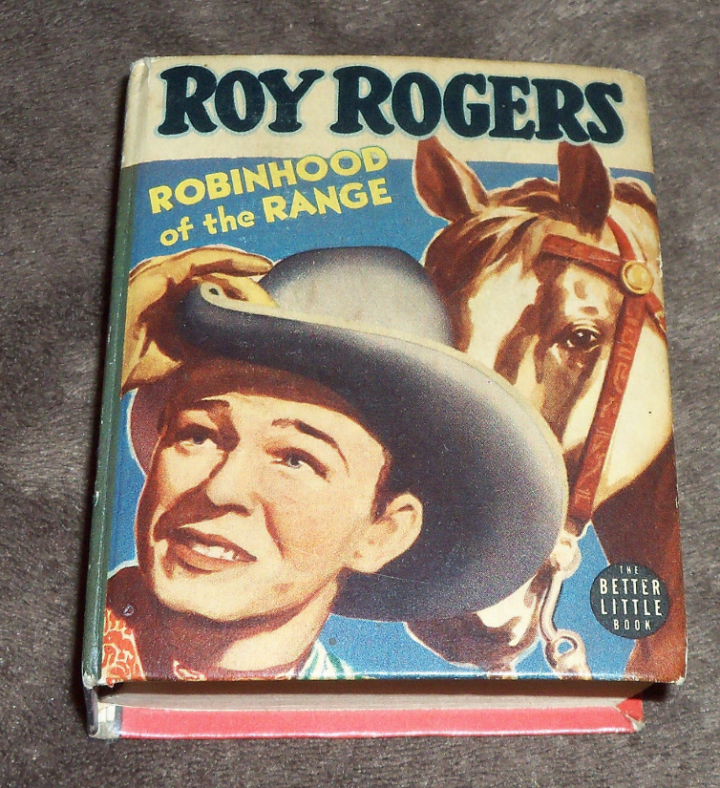

1942 no 1460

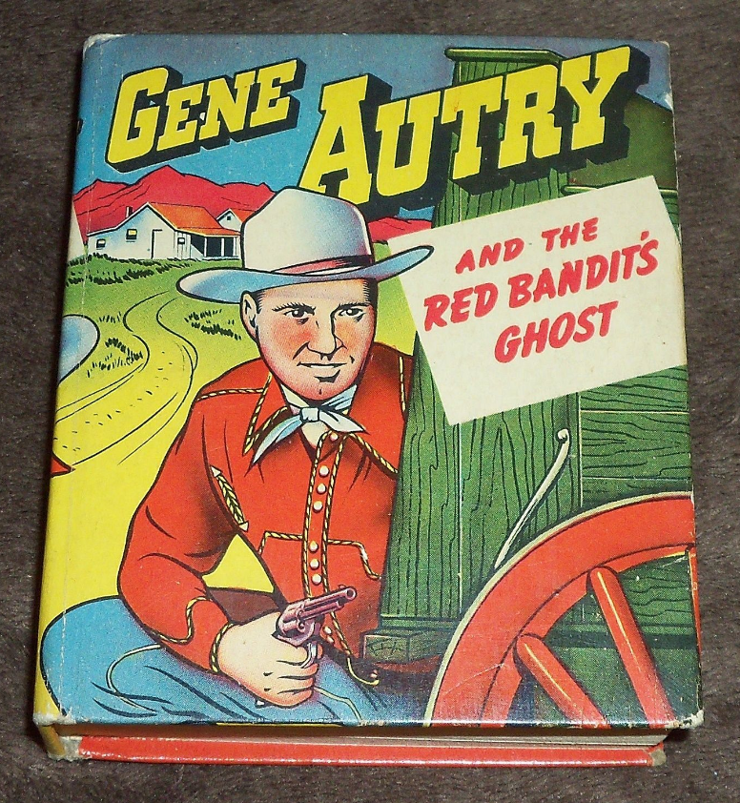

1949 no 1461

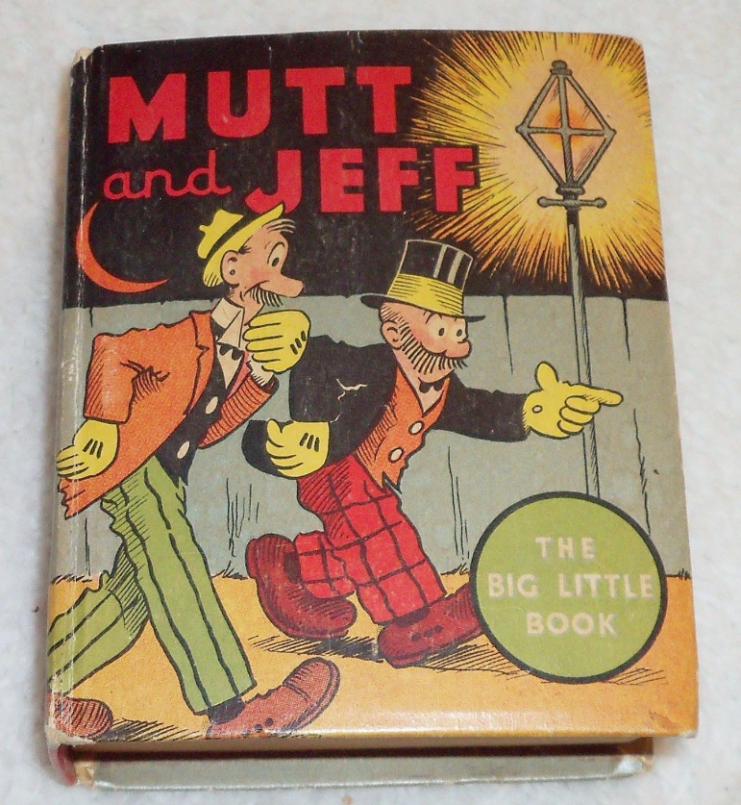

1936 no 1113

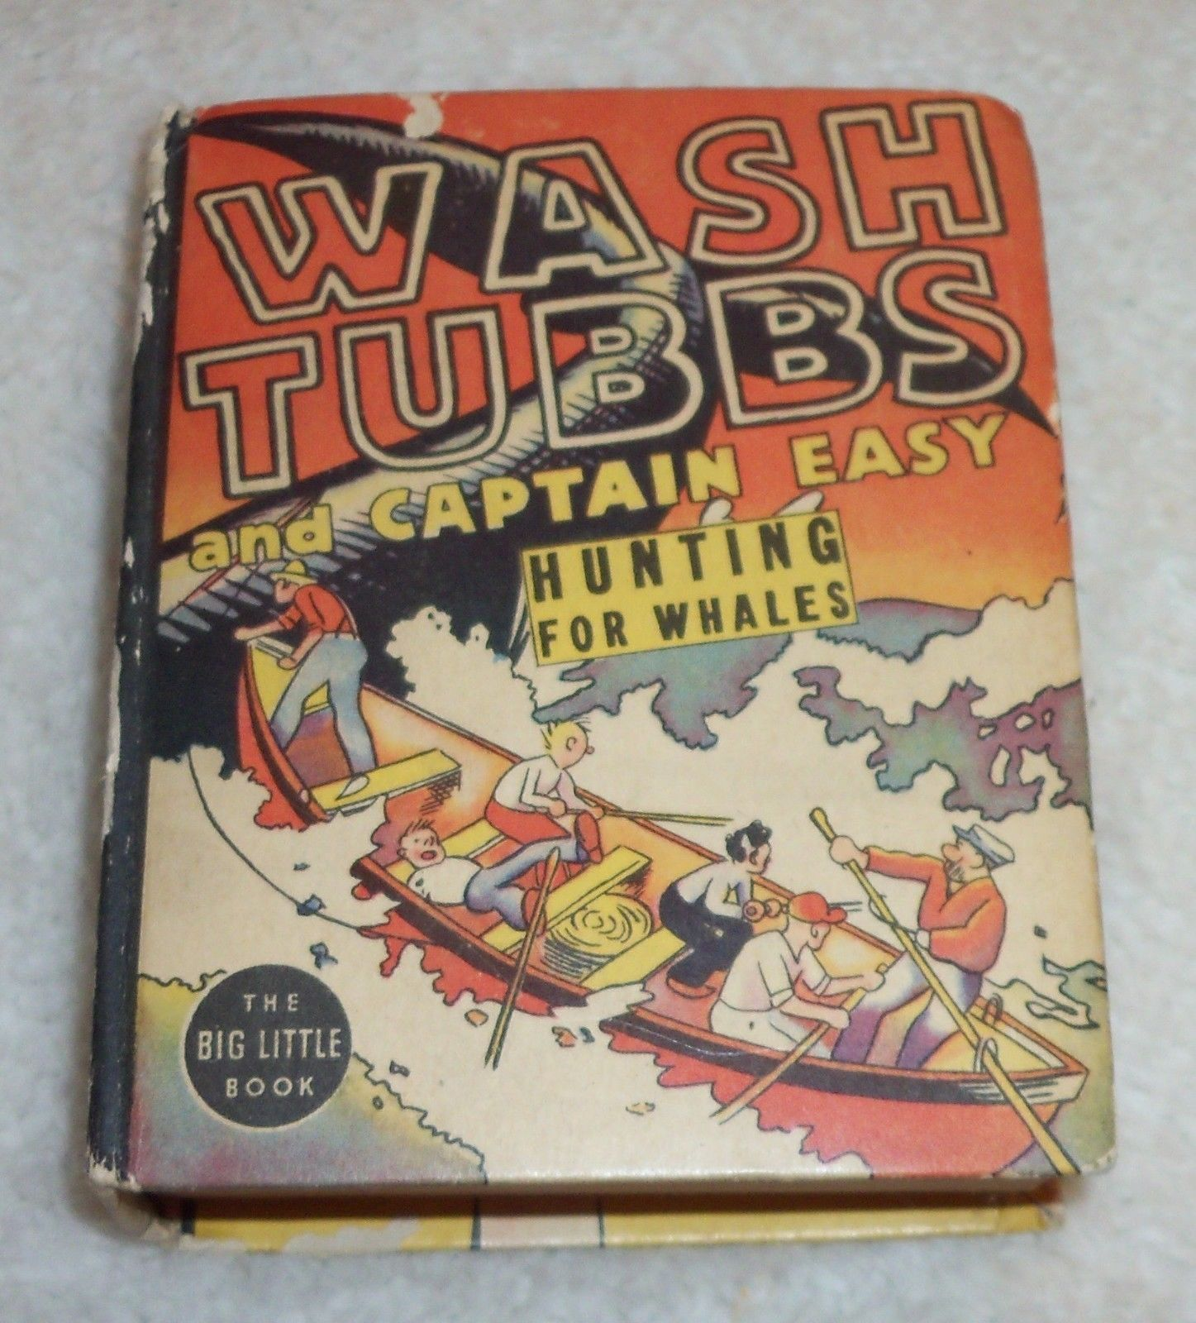

1938 no 1455

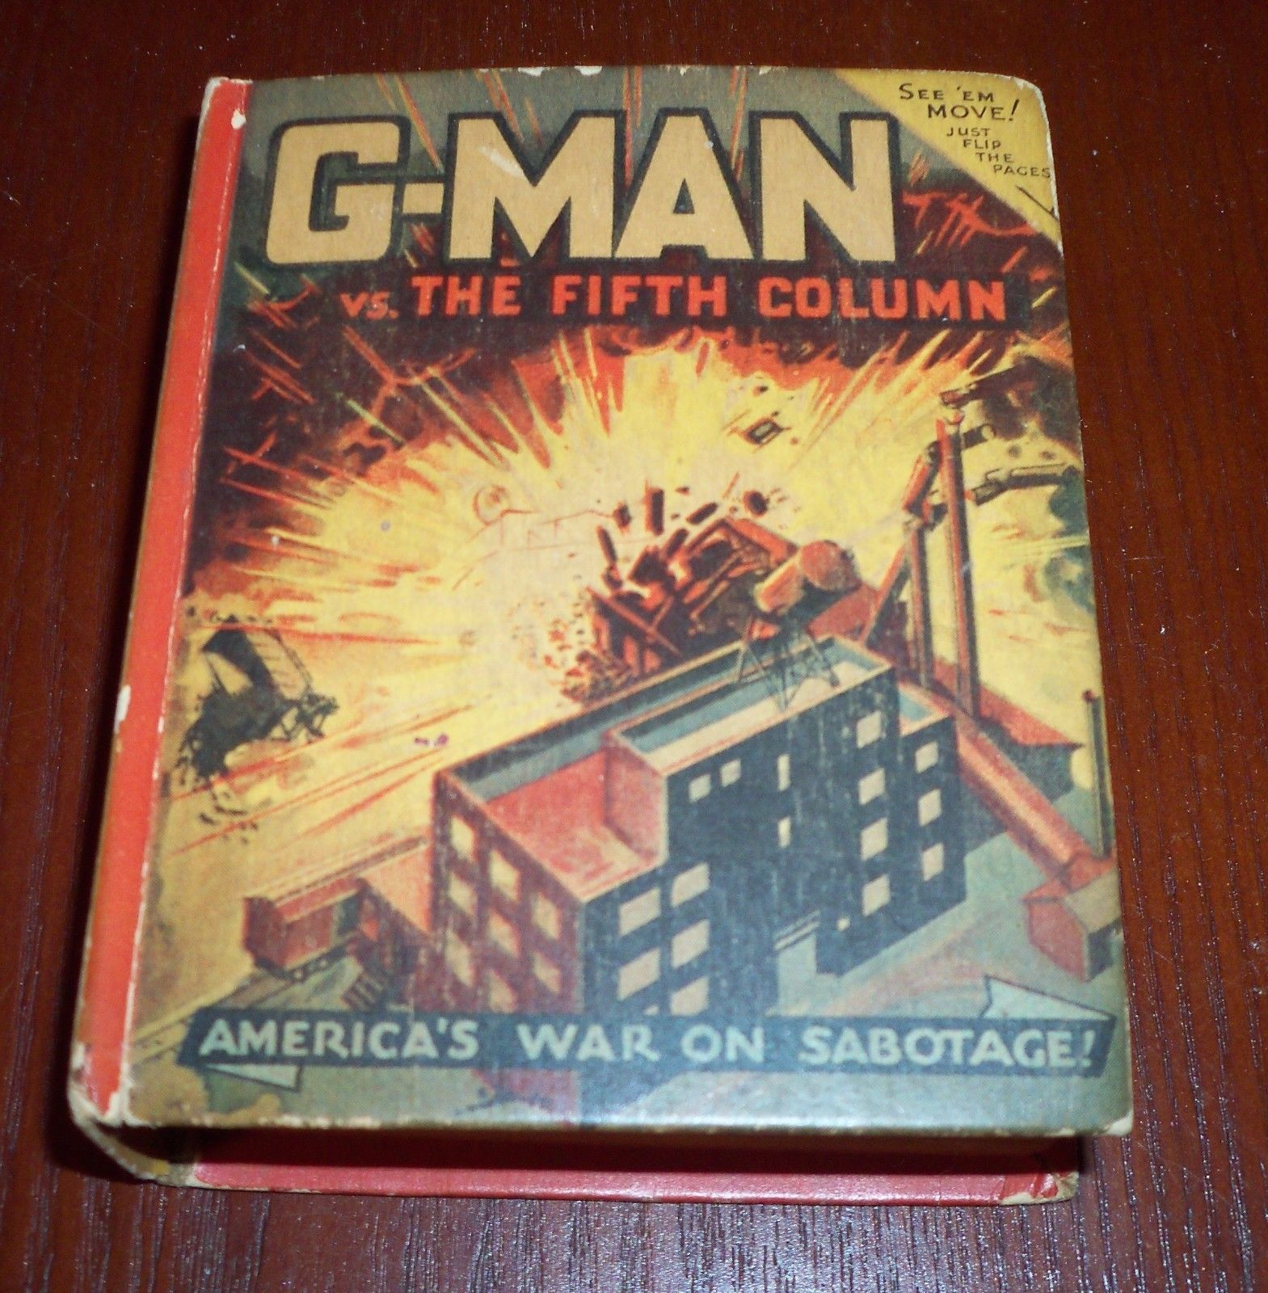

1941 no 1470

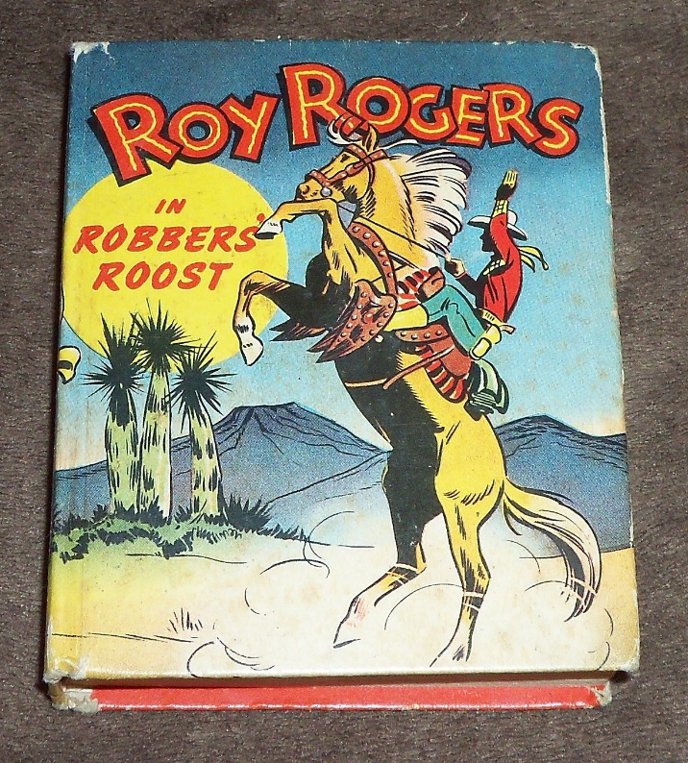

1948 no 1452